# Lab: Blog - PHP and Symfony

This document defines a complete walkthrough of creating a **Blog** application with the [Symfony](https://symfony.com/) Framework, from setting up the framework through the [authentication](http://symfony.com/doc/current/security.html) module, to creating a **CRUD** around [Doctrine](http://www.doctrine-project.org/) entities.

Make sure you have installed [XAMPP](https://www.apachefriends.org/download.html), [HeidiSQL](http://www.heidisql.com/download.php) and added [PHP root folder to the path environment variable](http://php.net/manual/en/faq.installation.php#faq.installation.addtopath).

**Chapters from I to III are for advanced users. There’s a** [**skeleton**](https://softuni.bg/downloads/svn/soft-tech/May-2017/Software-Technologies-July-2017/05.%20Software-Technologies-PHP-Blog-Basic-Functionality/05.%20Software-Technologies-PHP-Blog-Basic-Functionality-PHP-MySQL-Blog-Skeleton.zip) **which you can use and start from chapter IV.**

# Set Up Symfony Project

Symfony framework comes with various ways of creating a project, all of them involving the [presence of Symfony project](https://symfony.com/download). The most convenient way is to **create a project via your IDE**. Luckily there are several **plugins** for **PHPStorm** (and the other **IDEA**-based IDE’s) which help developing application with Symfony

## Install Symfony-related Plugins

Before we start working on our project, we can make our life easier by **installing** a couple of related **plugins**:

* Go to **[File]** 🡺 **[Settings]** 🡺 **[Plugins] 🡺 [Browse repositories]**:

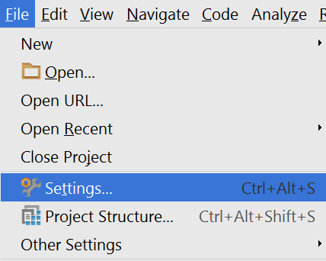

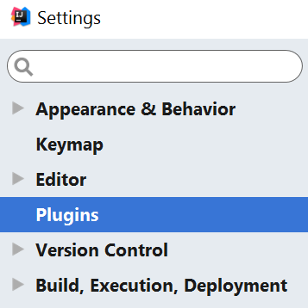

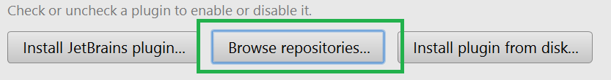

We need to install the following plugins:

1. Symfony Plugin

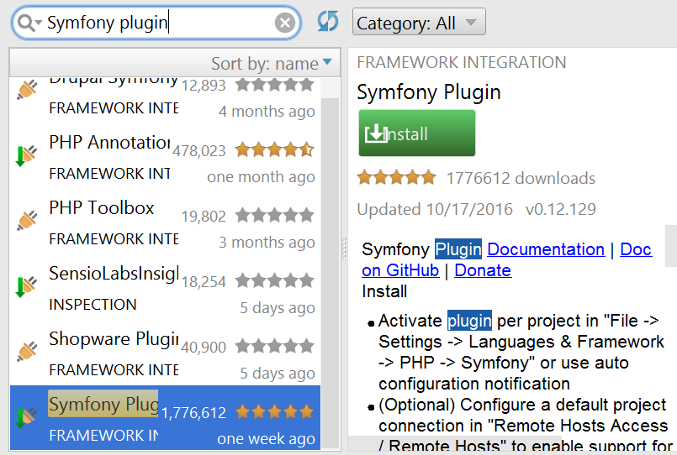

1. PHP Annotations

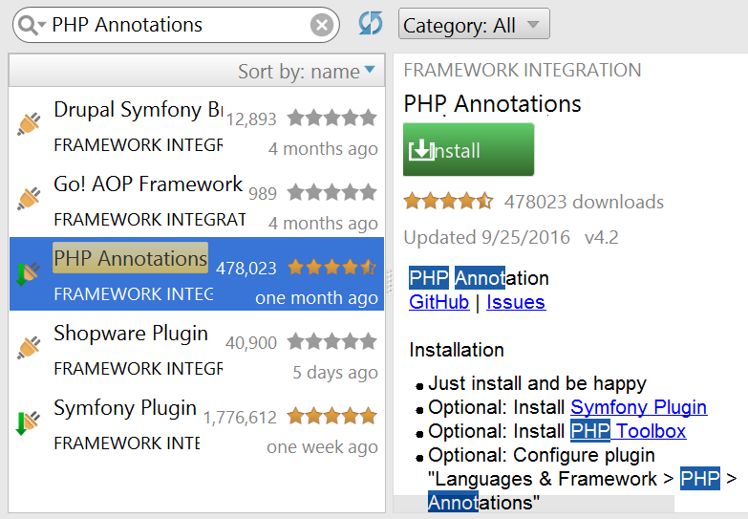

## Create Symfony Project from IDE

Once you have installed the plugins and restarted the **IDE**, you will have either a **PHP subcategory** (IntelliJ) or directly a **Symfony** one (PHPStorm) in the **Create Project** context menu:

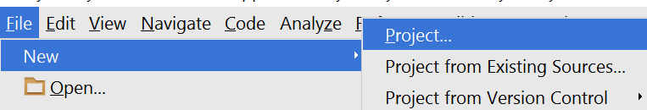

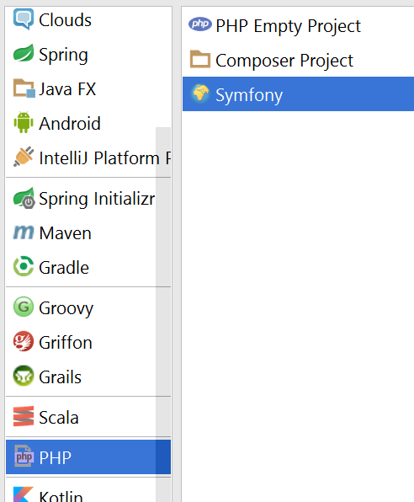

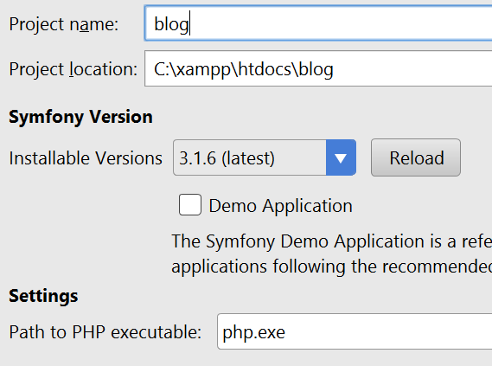

We need to specify the **php executable**, which most probably resides in **c:/xampp/php**

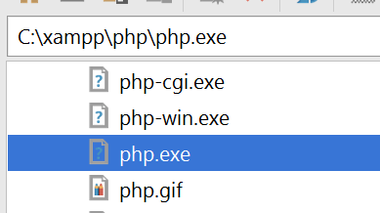

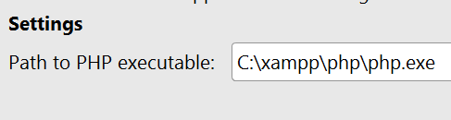

## Check Project Status

If you have received the following error:

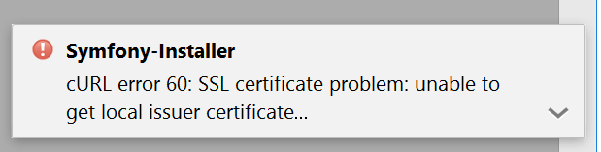

And your project looks like this:

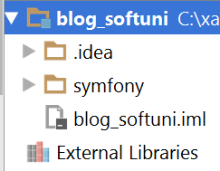

You most probably haven’t created the project properly. This could of possible missing curl.cainfo directive in **php.ini**.

Follow these [instructions](http://stackoverflow.com/questions/37997669/curl-error-60-ssl-certification-issue-when-attempting-to-use-symfony) **ONLY IF YOU HAVE RECEIVED THE ERROR ABOVE, OTHERWISE SKIP THIS STEP.**

1. Save this file: <https://curl.haxx.se/ca/cacert.pem> in **c:/xampp/php**
2. Edit the **c:/xampp/php/php.ini** file and find the following line

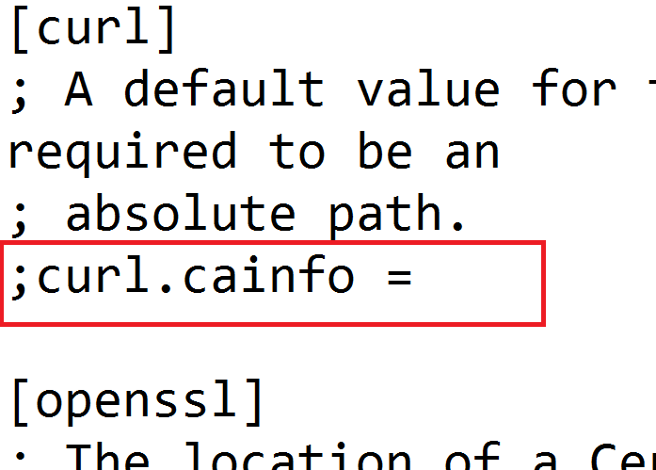

1. And make it: “curl.cainfo = c:\xampp\php\cacert.pem”

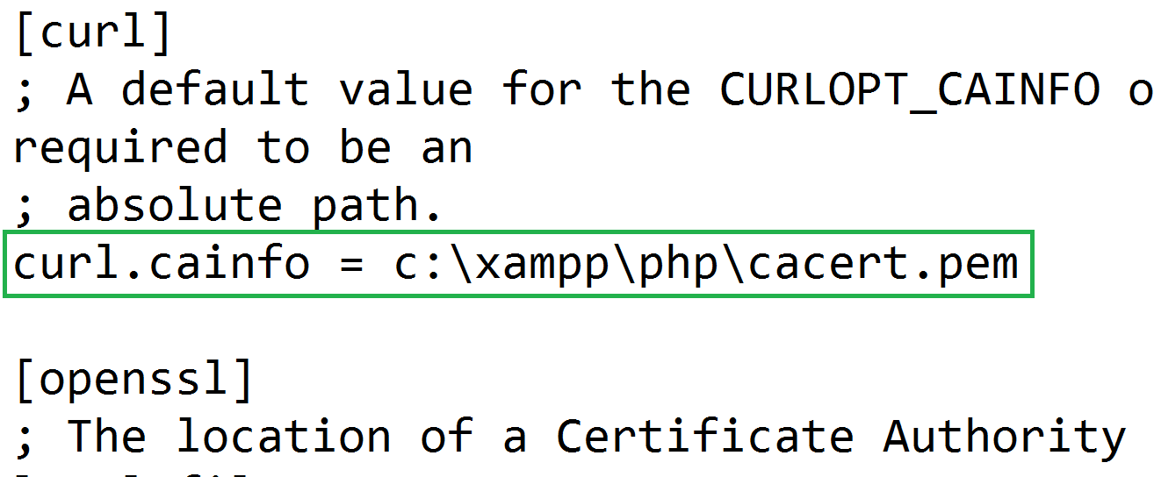

1. Create the project again

## Rename Default Bundle

The Default bundle located in src folder is called AppBundle. Rename with the following occurrences to SoftUniBlogBundle, using **[Shift+F6]**:

1. src/AppBundle folder
2. src/AppBundle/AppBundle.php
3. The namespace directive in src/AppBundle/AppBundle.php  
   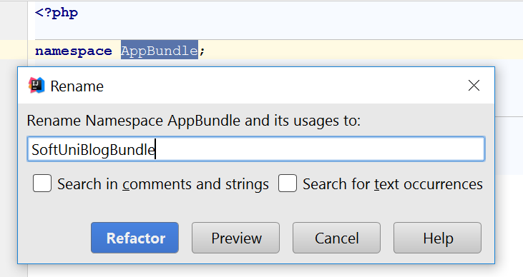
4. The classname in src/AppBundle/AppBundle.php  
   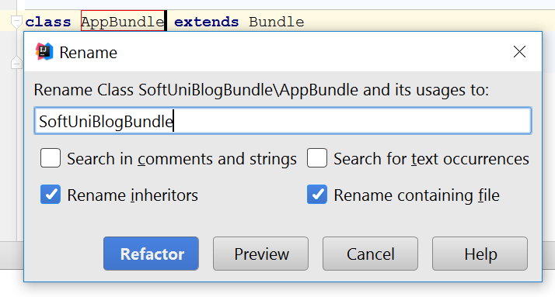

Change the occurrence in app/config/routing.yml to SoftUniBlogBundle too:

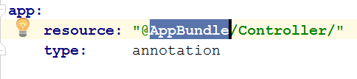

Start the server by running the following command in the project folder

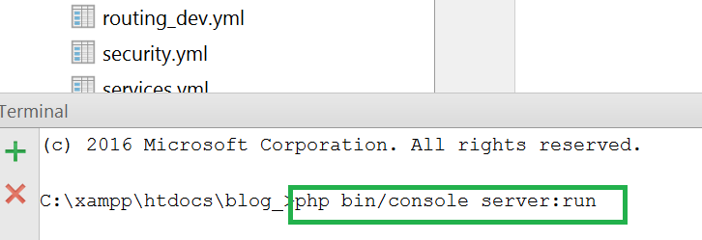

After that, you can see the result at <http://localhost:8000> ☺

## Create Database

Open HeidiSQL, connect to the MySQL instance and create a database named “blog”

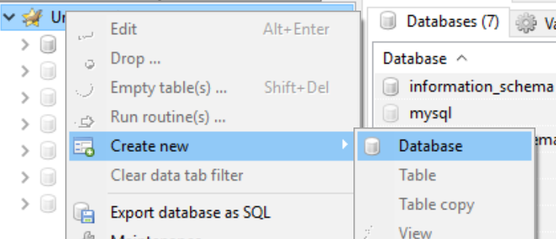

And change the database name in app/config/parameters.yml to “blog”

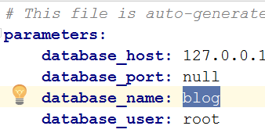

*Note: you also need to specify your* ***MySQL*** *database* ***root user password****:*

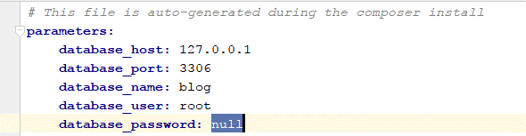

## Setup Layout

We will need a base layout for all our templates. As we are using **Bootstrap**, we will need its css included in all pages, and the related scripts too. We can download the sample **blog design skeleton** from [here](http://softuni.bg/downloads/svn/soft-tech/May-2017/Software-Technologies-July-2017/05.%20Software-Technologies-PHP-Blog-Basic-Functionality/05.%20Software-Technologies-PHP-Blog-Basic-Functionality-Blog-Design.zip), where part of our **JavaScript** and **CSS** is included. In addition, we will need:

1. [Bootstrap Date Time picker](http://www.malot.fr/bootstrap-datetimepicker/) for choosing dates in our forms
2. [Moment JS](http://momentjs.com/) for validating dates

All our styles and scripts we need to include to our project. Create two folders in the “web” folder called “css” and “js” respectively. In the **blog design skeleton** in the folder scripts you can find the jquery and bootstrap files.

Place the needed scripts and styles there, ending up with the following structure:

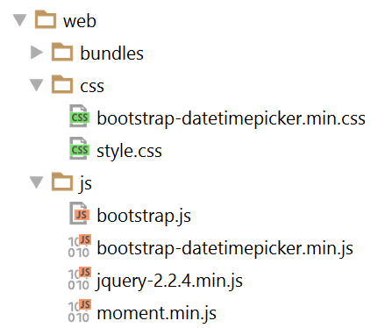

Then we need to use this styles and script setting up a base layout in app/resources/views/base.html.twig.

Setup a base layout as you wish or use the following one:

|  |
| --- |
| *{#  This is the base template used as the application layout which contains the  common elements and decorates all the other templates.  See http://symfony.com/doc/current/book/templating.html#template-inheritance-and-layouts #}* <!DOCTYPE **html**> <**html lang="en-US"**> <**head**>  <**meta charset="UTF-8"**/>  <**meta name="viewport" content="width=device-width, initial-scale=1"**/>  <**title**>{% **block** title %}SoftUni Blog{% **endblock** %}</**title**>  {% **block** stylesheets %}  <**link rel="stylesheet" href="**{{ asset(**'css/style.css'**) }}**"**>  <**link rel="stylesheet" href="**{{ asset(**'css/bootstrap-datetimepicker.min.css'**) }}**"**>  {% **endblock** %}  <**link rel="icon" type="image/x-icon" href="**{{ asset(**'favicon.ico'**) }}**"**/> </**head**>  <**body id="**{% **block** body_id %}{% **endblock** %}**"**>  {% **block** header %}  <**header**>  <**div class="navbar navbar-default navbar-static-top" role="navigation"**>  <**div class="container"**>  <**div class="navbar-header"**>  <**a href="**{{ path(**'blog_index'**) }}**" class="navbar-brand"**>SOFTUNI BLOG</**a**>  {% **if** app.user %}  <**a href="**{{ path(**'article_create'**) }}**" class="navbar-brand"**>  Create Article  </**a**>  {% **endif** %}  <**button type="button" class="navbar-toggle" data-toggle="collapse" data-target=".navbar-collapse"**>  <**span class="icon-bar"**></**span**>  <**span class="icon-bar"**></**span**>  <**span class="icon-bar"**></**span**>  </**button**>  </**div**>  <**div class="navbar-collapse collapse"**>  <**ul class="nav navbar-nav navbar-right"**>  {% **if** app.user %}  <**li**>  <**a href="**{{ path(**'user_profile'**) }}**"**>  My Profile  </**a**>  </**li**>  <**li**>  <**a href="**{{ path(**'security_logout'**) }}**"**>  Logout  </**a**>  </**li**>  {% **else** %}  <**li**>  <**a href="**{{ path(**'user_register'**) }}**"**>  REGISTER  </**a**>  </**li**>  <**li**>  <**a href="**{{ path(**'security_login'**) }}**"**>  LOGIN  </**a**>  </**li**>  {% **endif** %}  </**ul**>  </**div**>  </**div**>  </**div**>  </**header**> {% **endblock** %}  <**div class="container body-container"**>  {% **block** body %}  <**div class="row"**>  <**div id="main" class="col-sm-9"**>  {% **block** main %}{% **endblock** %}  </**div**>  </**div**>  {% **endblock** %} </**div**>  {% **block** footer %}  <**footer**>  <**div class="container modal-footer"**>  <**p**>**&copy;** 2016 - Software University Foundation</**p**>  </**div**>  </**footer**> {% **endblock** %}  {% **block** javascripts %}  <**script src="**{{ asset(**'js/jquery-2.2.4.min.js'**) }}**"**></**script**>  <**script src="**{{ asset(**'js/moment.min.js'**) }}**"**></**script**>  <**script src="**{{ asset(**'js/bootstrap.js'**) }}**"**></**script**>  <**script src="**{{ asset(**'js/bootstrap-datetimepicker.min.js'**) }}**"**></**script**> {% **endblock** %}  </**body**> </**html**> |

# Symfony Base Project Overview

Symfony is a modular enterprise web-framework, which comes with a solid vendor support, **bundle** system, **enterprise** mechanisms and is most-suited for **MVC** architecture.

Initially the project comes with a main [bundle](http://symfony.com/doc/current/bundles.html), which can be treated as a plugin later. A **bundle** often has **Controllers**, **Entities** and related components (e.g. **Repositories**, **Forms**, **Commands**…)

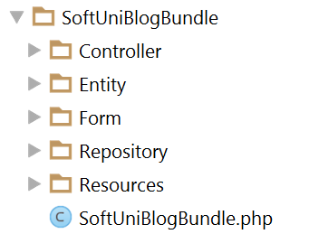

Standard templates (**views**) reside in the application folder (app) and are usually separated in a folder named after the **controller names**.

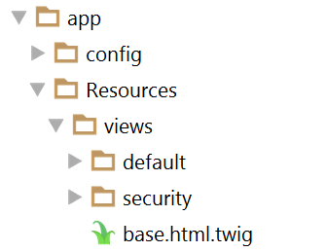

The de-facto standard **View Engine** in Symfony is [Twig](http://twig.sensiolabs.org/).

The base **configuration** of the project is placed in app/config, where configuration files for the [Doctrine](http://www.doctrine-project.org/) connection are defined among [Security](http://symfony.com/doc/current/security.html) management, [Routing](http://symfony.com/doc/current/routing.html) rules, registering [Services](http://symfony.com/doc/current/service_container.html) and so forth.

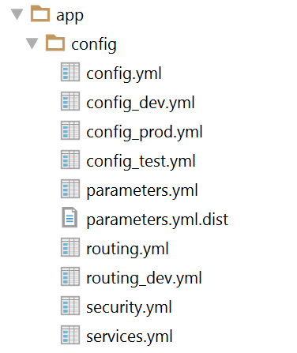

It's very important that the parameters.yml.dist file contains the **same** keys as the ones in parameters.yml, since installing a new bundle will **delete** **unused pairs**.

# User Authentication

Symfony has very powerful **security** management system, where the common work for checking user **permissions and dispatching the request** is well abstracted, yet the configuration could be confusing. In the walkthrough below, we will setup a **registration and login process** and accessing **secured** content.

## Creating User Entity

Our users should be stored in the database. This means we need a “users” table. Since tables are represented as objects in the **Object/Relation Mapping** paradigm, we need to create an **object, which represents that table**. The **classes** (**objects**) which represent tables are called **Models** and **Entities**.

In the de-facto, standard **ORM** in Symfony, called **Doctrine**, these objects are called **Entities.**

Let’s define our rules for a user:

* Should have a **unique** login name, let’s say email
* Should have a password
* Should have a full name, let’s say fullName

Doctrine comes with a [handy console tool](http://symfony.com/doc/current/doctrine/console.html) for managing the database and creating entities. Let’s use Doctrine to create an entity called User, using the entity generation wizard. To do this, we need to open a terminal window in the project root directory and type the following command:

|  |
| --- |
| **php bin/console doctrine:generate:entit**y |

This will prompt us to enter an entity name. Entities are prefixed with the bundle they should belong to. Our bundle is called SoftUniBlogBundle (the default name is AppBundle), so we’ll type in SoftUniBlogBundle:User (or AppBundle:User, if your bundle is called AppBundle).

Afterwards it will prompt us for the properties (fields) of the User object. As we have said above, it will have an email, password and a fullName, all of them are text fields (strings). The email should be unique, so when you are prompted for uniqueness there, type “true” instead of just clicking enter (which defaults to false)

When the last field (fullName) is created and you are prompted for another one, just click enter to exit the wizard. This will create the User entity and its corresponding UserRepository.

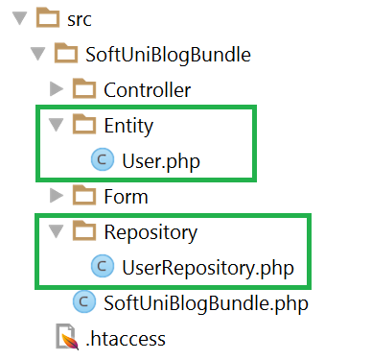

## Setting Up Security Configuration

As we have said, Symfony comes with a couple of configuration files, one of which is called security.yml. We need to specify a few things, such as:

* How the password will be **encrypted** and on **which entity**
* **Which** entity will be used for **users** and which of its **fields** will be the **username field** (e.g. **email**, **username**, etc.)
* **Where the login form will be located** (route name)
* Where this **login form will post to**

Below is a security.yml file, which has the following configuration:

* The bundle is called SoftUniBlogBundle
* The **user** entity is called User, and its username field is called email
* The login form will be accessed and posted to “security_login”
* After a successful login, the user will be redirected to “blog_index”

|  |
| --- |
| **security:  encoders:** *# Our user class and the algorithm we'll use to encode passwords  # http://symfony.com/doc/current/book/security.html#encoding-the-user-s-password* **SoftUniBlogBundle\Entity\User:** bcrypt   **providers:** *# in this example, users are stored via Doctrine in the database  # To see the users at src/AppBundle/DataFixtures/ORM/LoadFixtures.php  # To load users from somewhere else: http://symfony.com/doc/current/cookbook/security/custom_provider.html* **database_users:  entity:** { **class:** SoftUniBlogBundle:User, **property:** email }   *# http://symfony.com/doc/current/book/security.html#firewalls-authentication* **firewalls:  secured_area:** *# this firewall applies to all URLs* **pattern:** ^/   *# but the firewall does not require login on every page  # denying access is done in access_control or in your controllers* **anonymous:** true   *# This allows the user to login by submitting a username and password  # Reference: http://symfony.com/doc/current/cookbook/security/form_login_setup.html* **form_login:** *# The route name that the login form submits to* **check_path:** security_login  *# The name of the route where the login form lives  # When the user tries to access a protected page, they are redirected here* **login_path:** security_login  *# Secure the login form against CSRF  # Reference: http://symfony.com/doc/current/cookbook/security/csrf_in_login_form.html* **csrf_token_generator:** security.csrf.token_manager   **logout:** *# The route name the user can go to in order to logout* **path:** security_logout  *# The name of the route to redirect to after logging out* **target:** blog_index    **access_control:** *# this is a catch-all for the admin area  # additional security lives in the controllers # - { path: '^/(%locale%)/admin', roles: ROLE_ADMIN }* |

## Login Form

To create a login form, we need to create a so-called Controller which will **listen on** this **route** (which above we called “security_login”) and render the View with the login form when someone goes to the /login route.

Let’s call our Controller “SecurityController“:

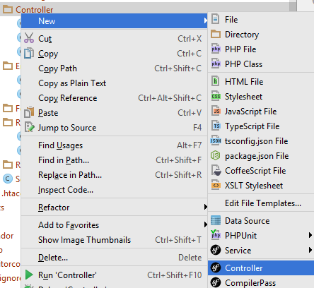

Then we need a method (which we will call “login()”), which listens on the “/login” **route** and renders a view (let’s point it to a login.html.twig file, which resides in the security **folder**)

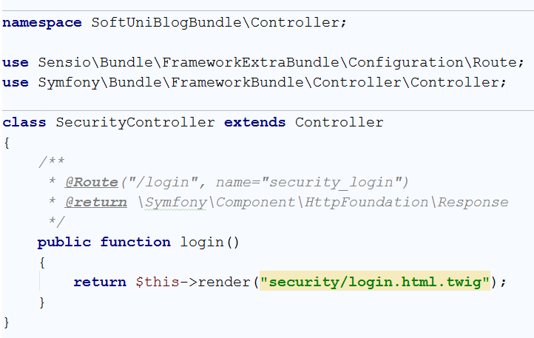

The yellow background color in the view name tells us we don’t have that view yet. We could easily create it by clicking [Alt+Enter] ☺

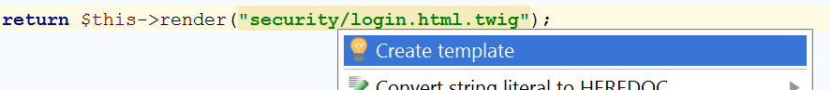

Before messing with any layouts (which we have setup and will use in the next chapters) we will just create a simple login form with no styles.

We need to define a <form> tag, which is posting to the security_login route. **Twig**, fortunately, provides a function path() that uses route names and generates URLs from them



The form is named “**authenticate**” because we will use this name later to generate a [CSRF Token](https://en.wikipedia.org/wiki/Cross-site_request_forgery)

Symfony security requires the **username** (which is **email** in our case) and **password** fields to be named respectively _username and _password

We need to define these two text fields (or **password** field for the password type ☺)

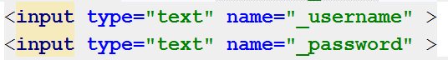

And a field for the CSRF Token using the Twig’s helper method csrf_token() which accepts the form name.



Now opening <http://localhost:8000/login> should render this login form

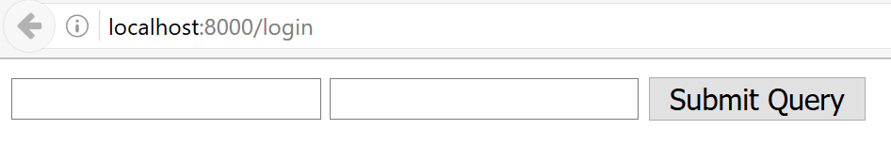

Not the most beautiful login form ☺ But still it’s there! ☺

## Register Form

What is a login form without users – nothing. In order to have users, we need a registration form. By analogy, open the already generated DefaultController or create a new one (e.g. UsersController) and an action that listens on “register”.

It will render the form the same way, but also needs to handle this form.

In order for a form to work with an entity, it needs a corresponding [FormType](http://symfony.com/doc/current/form/data_transformers.html). Before we can continue creating the register action, we need to create a Form Type. Create a folder “**Form**” in src/SoftUniBlogBundle. Then create a **Form Type** as follows:

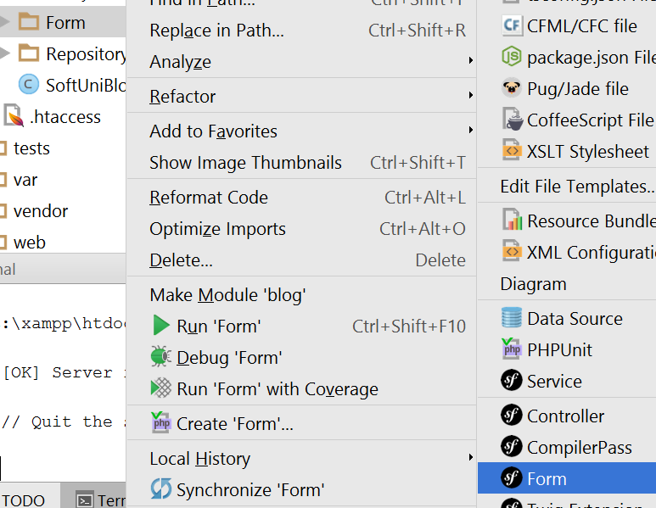

Let’s call it UserType.

In the scaffold method “buildForm()” we need to the define pairs – the entity fields and their corresponding types in the form. All our three fields are text types, so we will use a TextType from the Symfony\Component\Form\Extension\Core\Type\TextType namespace.

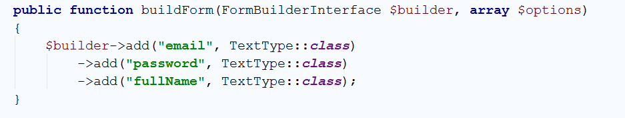

Going back to the controller’s registration method we can now create a form of UserType.

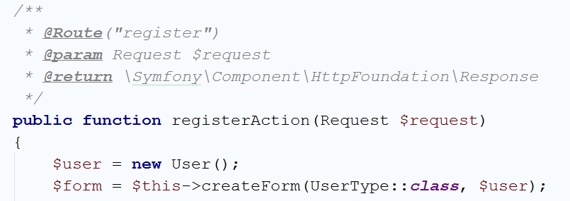

We have said here: Create a form of user type and after it’s submitted fill the $user object.

Then we need to tell the method – once the form is **submitted** and **all** the validations are **passed** (e.g. texts are filled), **save** the user entity in the **database**.

There’s one possible problem – the password will go **plain** into the DB. Luckily, in the security configuration we have registered an encryption provider, so we can use this provider to encode the password and then send it to the database

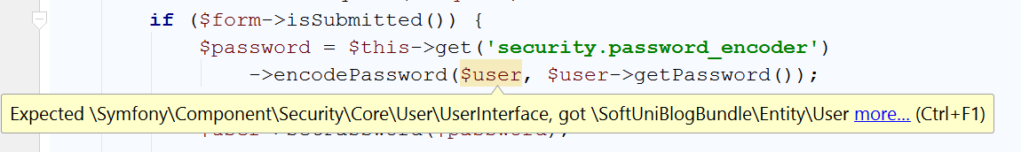

The encoder only works on **UserInterface** objects and our users is not one. What we need is to go to the User entity and make it implements the **UserInterface** interface.

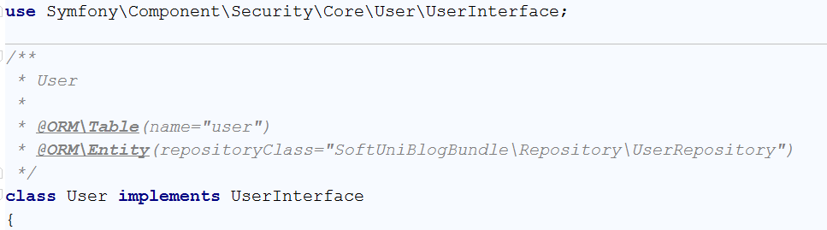

Then implement all of the missing methods with [ALT+ENTER].

You can leave most of the blank (auto-generated), but some of them should be filled.

The first method is getRoles(). It should return an array of roles (could be empty), but not null:

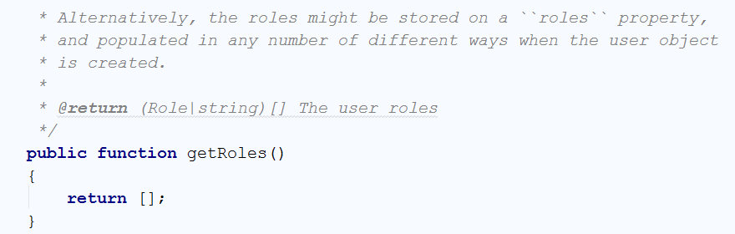

The other one is the getUsername() method, which will be used for authentication. We need to return our $email field in it, because that’s our username:

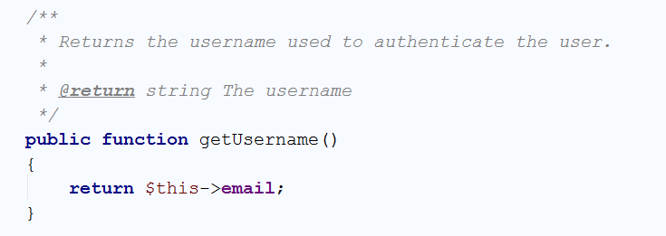

Now going back to the registration action, the error is gone. We can safely set the encoded password to the user object and persist it via [EntityManager](http://www.doctrine-project.org/api/orm/2.5/class-Doctrine.ORM.EntityManager.html) to the database

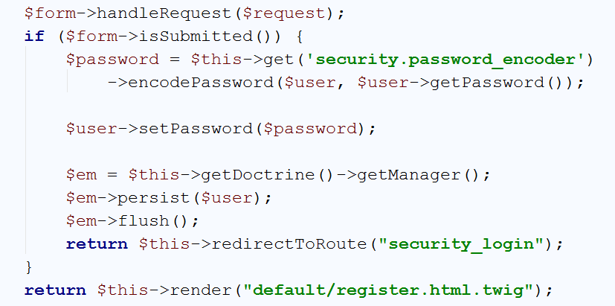

Here we have said that when everything is OK with the form, persist the user and redirect them to the login form. If the form is not submitted, then we need only to render the register form ☺

The form itself contains text fields with names corresponding to the object name and the properties as keys (like an associative array) e.g. the email field is called **user[email]:**

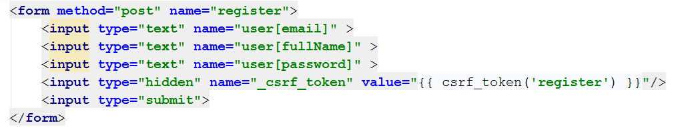

Open <http://localhost:8000/register> and test it:

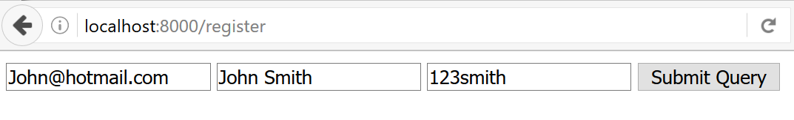

# Creating Articles

## Start MySQL (Only if you are here from the start)

**Skip this step if you have gone through the above III chapters.**

If you are still reading:

Download the [project skeleton](https://softuni.bg/downloads/svn/soft-tech/May-2017/Software-Technologies-July-2017/05.%20Software-Technologies-PHP-Blog-Basic-Functionality/05.%20Software-Technologies-PHP-Blog-Basic-Functionality-PHP-MySQL-Blog-Skeleton.zip), extract it in a shortest path you can make, e.g. in **c:\project**.

Before we start using our blog, we need to **create** a [database](https://en.wikipedia.org/wiki/Relational_database). We will use [MySQL](https://www.mysql.com/), which you are given in the skeleton. To start using MySQL, just **double-click** **mysql_start.bat** from the root directory (e.g. **c:\project**). You will see a window like this one:

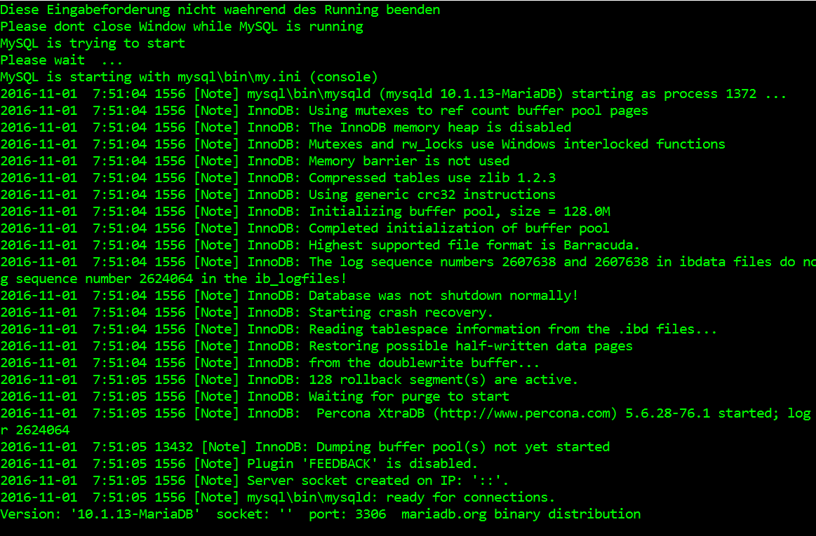

That’s it, MySQL is running. When you decide to stop working on the blog, just close the terminal and run the **mysql_stop.bat** file.

## Open the Project (Only if you have done step 0.)

**Skip this step if you have gone through the above III chapters.**

If you are still reading:

For this step, we will open the project with **PhpStorm** or **IntelliJ** Idea. Starting from the home screen, click on “**Open**”:

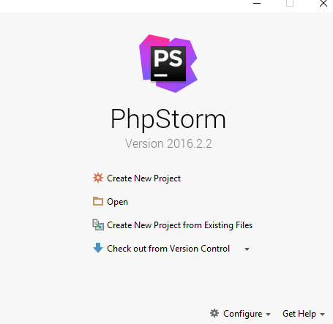

Locate the skeleton folder that we gave to you and select the “**Blog**” **folder** from the extracted folder (e.g. **c:\project\Blog**):

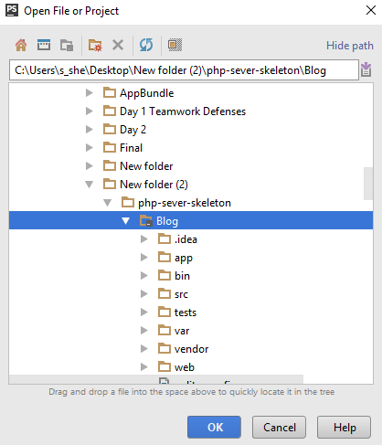

After you click “**OK**” the project should start loading and indexing. After a few seconds/minutes depending on your pc, you will be able to work with the project.

## Create the Article Entity

Open **Terminal** or **Command Prompt** (CMD) in the blog project root folder. Let’s model our articles. That means that we are going to create the defining properties of an article. To do that, we need to generate a [Doctrine Entity](http://docs.doctrine-project.org/en/latest/reference/working-with-objects.html). Our entity will describe what are we going to store in our database. The following command will **start entity generator wizard**:

|  |
| --- |
| php bin/console doctrine:generate:entity |

You should see this result:

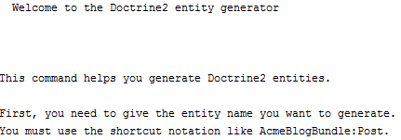

Now we need to choose **appropriate name for our entity**. Use the following name:

|  |
| --- |
| Date |

The result should be the following:



Just press **[Enter]**. Now we need to **define the properties** for our entity. you should see this:

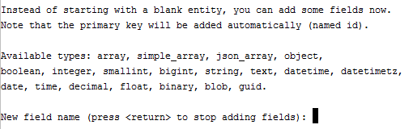

Our **first** **field** will be the “**title**” of our article. Just write “**title**” and press **[Enter]**. You should see this:



Press **[Enter]**. You should see “**Field length [255]**”. Press ‘**Enter**’ again. You will be asked if you want to make the field **nullable**. Press **[Enter]**. Finally, you will be asked to make your field **unique**. Just press **[Enter]** one more time. Now you should see this:

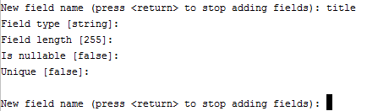

Similar to this, we should create 2 more fields for the “**content**” and “**dateAdded**”. Here is how we create them:

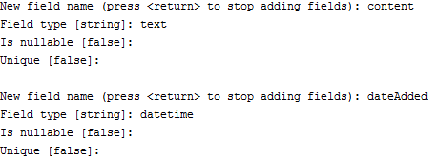

Finally, press ‘**Enter**’ one more time to close the wizard. You should see this:

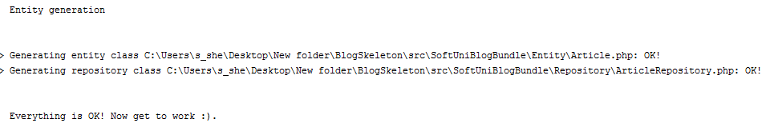

Let’s see the project in **PhpStorm** (IntelliJ Idea):

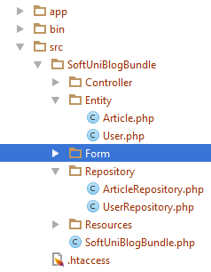

Okay, Doctrine has created “**Article**” entity and “ArticleRepository”, which is a special type of class. Its job is to manage our data and simplify our work with the database.

## Add Summary to the Article Entity

Let’s go into the “**Article**” entity that Doctrine created in the previous step. It should contain all of the fields, that we created using the terminal, plus one **special** “**id**” **field**. It is the [primary key](http://www.mysqltutorial.org/mysql-primary-key/) for our table. On top of our entity we should see something that looks like a comment:

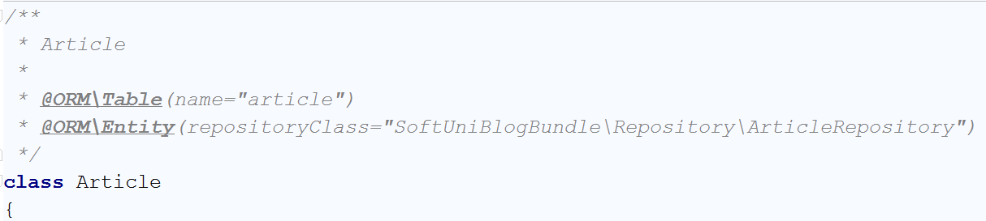

However, this is not just a comment. It is an annotation. More specifically, it is a [Doctrine Annotation](http://docs.doctrine-project.org/projects/doctrine-common/en/latest/reference/annotations.html). It tells Doctrine how are the tables and fields are going to be called in the database. At first glance, we see the annotation

|  |
| --- |
| * @ORM\Table(name="article") |

This defines the name of our table in the database. The names of the tables in the database should be pluralized. For that reason, rename the table to “**articles**”.

Now we need to create some fields, that will not get saved into the database. Find the “$dateAdded” field. You should see something like this:

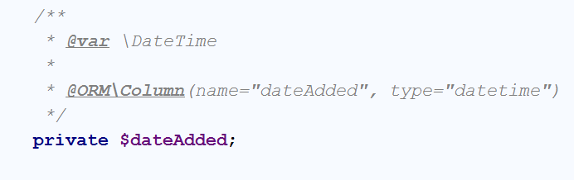

Below that, first add a new private field called “summary”. It will hold the short summary of the article:

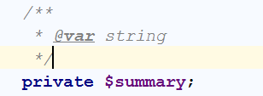

Then we need to create [Mutator and Accessor](http://www.refulz.com/mutator-and-accessor-methods-in-php/) (Getter and Setter) **methods** for the summary. Let’s first start with the **mutator**. Its job is to **set the value** of the summary to **half of the article content**. The code should look like this:

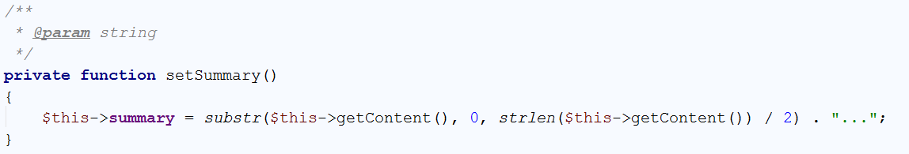

Now we should create the **accessor**. It should simply **return the saved value** in our **summary** variable. However, if summary is empty, it should **call the** **mutator to set the value**:

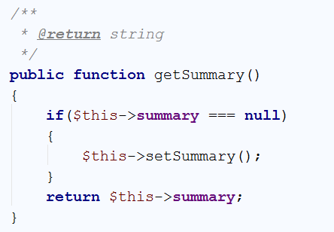

We’re done with the summary variable, but we still have more variable to implement.

## Create a Relationship between the User and the Article

We’ve come to the part where we must connect each user with his articles. To do that, we will create 2 more field in the “**Article**” entity. Just below the private summary field, that we’ve created in the previous step, create new private field called “authorId”. Using that field, each article will know who is its author:

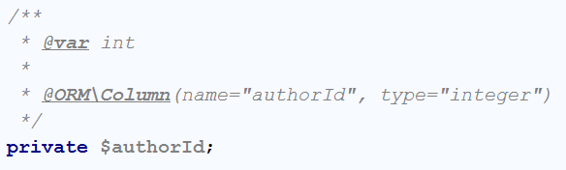

You have probably noticed that we’re going to **save this field in the table** using the @ORM annotation. This will **create a column in the table**, which will keep integer, representing a user. Similarly, to the summary, we need to create **getter and setter** methods for this field. Again, we’re starting with the mutator:

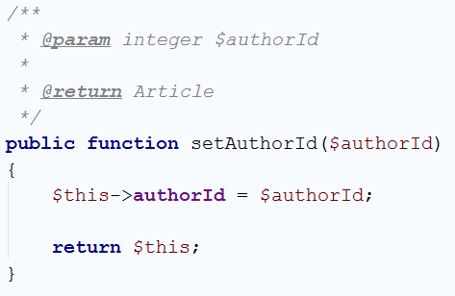

One special thing to note here is that the **mutator** actually returns the object, that it changes. Now simply **create the accessor**:

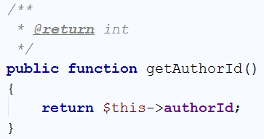

We’re done with the authorId, but the **connection** is **not** **ready** yet. In order for our article to actually have an author, we need to declare a private field of type “**User**”:

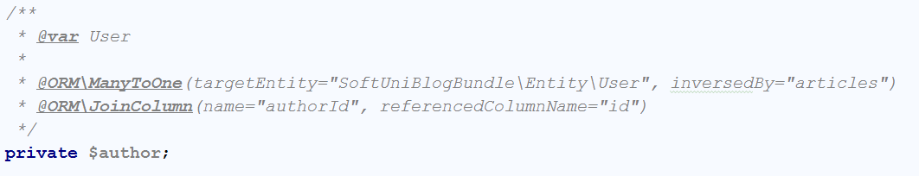

More new stuff! We’re using 2 new annotations. The first one is the “ManyToOne” annotation. A **many to one** relationship represents a [One To Many](https://en.wikipedia.org/wiki/One-to-many_(data_model)) relationship from the side of the “**many**”. In our case, we will use a “**one to many relationship**” to tell the program that **one user** will have **many articles**. Because we are working with the Article entity, we are telling Doctrine that **many of our articles** will correspond **to one user**. The “inversedBy” parameters tells Doctrine that the User entity will have a private field called “**articles**”, which will keep all of the **articles** of **one user**. The other annotation is “JoinColumn”, which tells Doctrine how are we going to connect the fields in our entities. Our annotation tells Doctrine that the **field “**authorId**” in our article entity will correspond to the “id” field from the** Userentity.

Now we should create the **setter** for the author field:

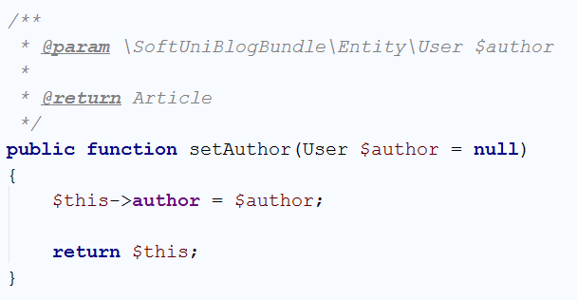

And our **getter**:

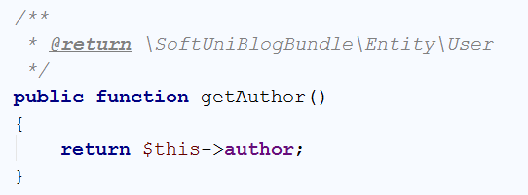

That’s it, we’re done with the Article entity for this step. We need to do the “one to many relationship” on the side of the User entity. Just below the private “password” field, create the following field:

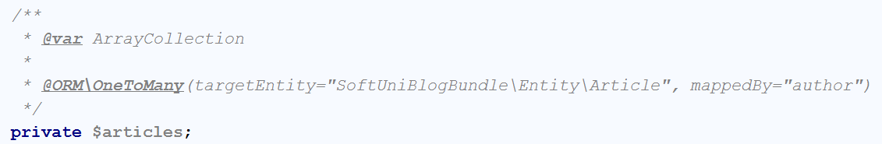

This field will be of type ArrayCollection, that will keep all of the current user posts. As you can see, we define one-to-many relationship with the Article entity, using the author field, we’ve created earlier. For this field, **we won’t create setter** like for previous ones. Firstly, we should create the getter:

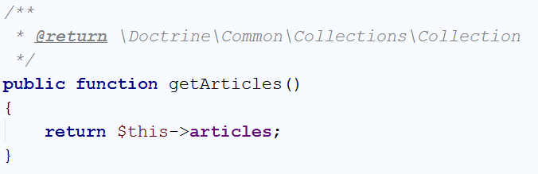

The setter however will be slightly different. It should **add a new post to the current user posts**. To do that, we should write the following code:

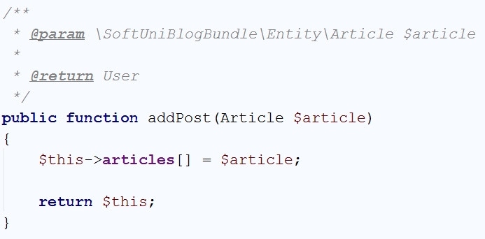

We’re done with the connection for now. Later **we will update the database** schema.

## Set Default Values for our Entities

Our next job is to create the so-called [constructors](http://php.net/manual/en/oop4.constructor.php) for our entities. The constructors are special methods that are called **each time a new object from the entity is created**. Let’s start with the User entity. Its constructor should be the following:

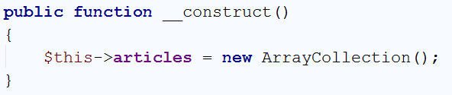

Every time we create a new user, it will receive empty array of articles. The Article on the other hand should look like this:

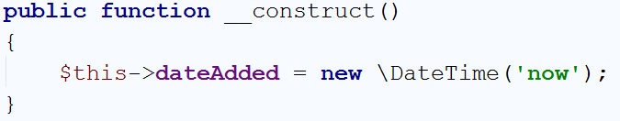

Each time a new article is created, this constructor will add the current time.

We are ready with this part, now **we can update the database**(schema).

## Updating the DB with our Article Entity

There are many ways to update or create the tables that we need. The first one is to create them **manually**. That will take a lot of time and because of that we won’t do it that way. We will create them **using** [Doctrine](http://docs.doctrine-project.org/en/latest/). **Open** a **Terminal**/**CMD** in the project **root** **folder**. Let’s write the following command:

|  |
| --- |
| php bin/console doctrine:schema:update |

This will result in the following warning:

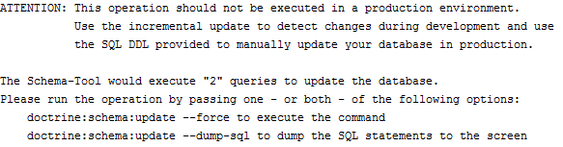

It basically tells us, that we are doing an operation that is not safe. To do it, **we need to force Doctrine** to execute our command. In order to do that we need to add “**--force**” after our previous command:

|  |
| --- |
| php bin/console doctrine:schema:update --force |

The result of this command should be the following:



If we take a **look at the DB in HeidiSQL**, we will see that the table “**articles**” is created:



We are ready, to start making our blog.

## Creating the Article Controller

Now we should create a class that will control how the articles are going to be viewed, created, edited and deleted. We will create it in the **Controller** folder. If you are using **PhpStorm or IntelliJ IDEA** and you have the **Symfony plugin installed**, you should see this when you right-click on the Controller folder:



Give it the name ArticleController:

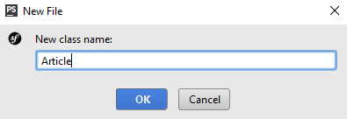

We have just created an ArticleController in the **Controller** folder, that looks like this:

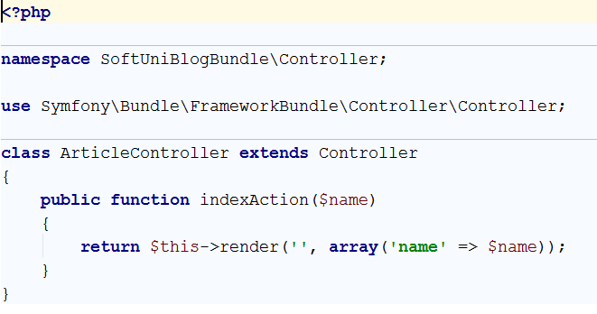

Delete the indexAction method, we won’t need it. We should be happy with the following result:

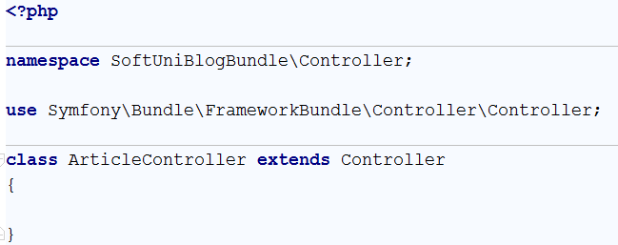

We have a controller, but we need **form template**.

## Creating the Article Type Form

Our next step is to **create a form template**, that we are going to fill, each time when we’re **creating or editing** an article. To create this form, just right-click on the **Form** folder and choose new **Form**:

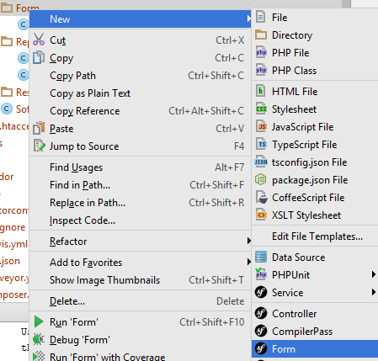

Give it the name “ArticleType”:

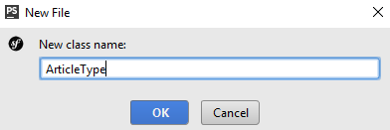

We should receive something like this:

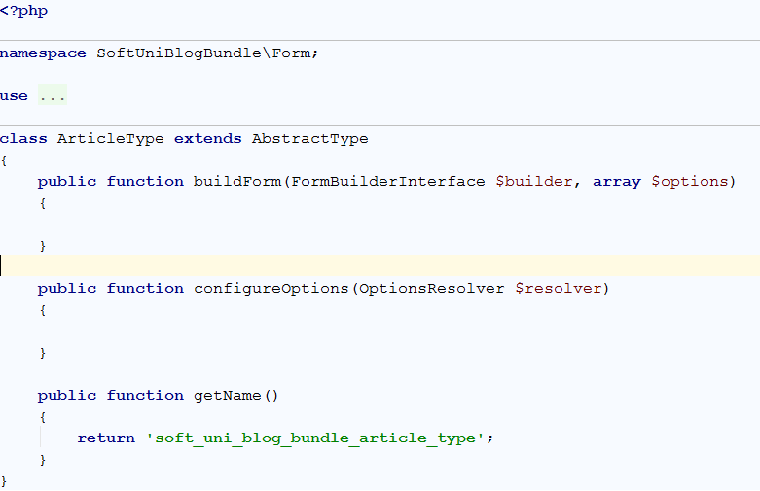

You may notice that we have 2 empty functions. “buildForm” will create our form and “configureOptions” will tell our form that it is for the Article entity. Let’s start with the form creator:

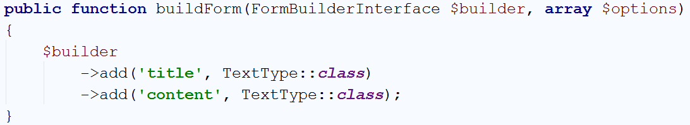

It’s a pretty simple form. It should only contain **title** and **content** fields, both of type text. You should use specific using for the “TextType” to work. If you have another one **ending in \TextType** already imported – delete it and add:

|  |
| --- |
| **use** Symfony\Component\Form\Extension\Core\Type\TextType; |

Let’s create the logic for our “configureOptions” function:

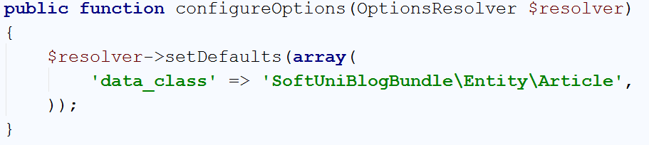

The default value for our resolver **tells controller that is going to use the form**, in what type of object it should save the date from our form. That’s it.

## Implementing Article Create Function

Go back to the article controller, we need to create a new function. We will name it “createAction” and create few annotations for it:

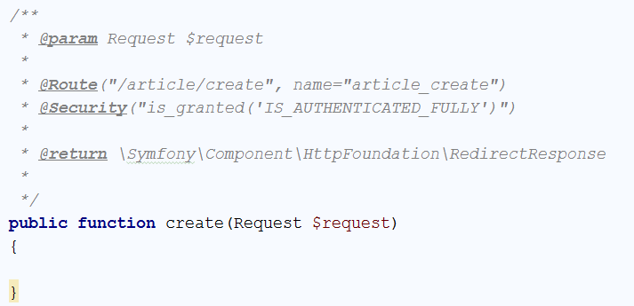

Let’s start from the first annotation. It tells our project that the function will receive **one parameter** of type [Request](http://api.symfony.com/3.1/Symfony/Component/HttpFoundation/Request.html). We will save what request is for some other time. The second annotation is more interesting. It defines a “[Route](http://symfony.com/doc/current/routing.html)”. The **route represents** the **URL**, that the **current** **method will correspond to**. In this case the function will be called when we go to <http://localhost:8000/article/create>. Each time we **use this URL**, the router will **call our function**. To **simplify** the **redirection** between our **pages**, we give a simpler name like “article_create”. The third annotation is to make sure, that only **logged in users** will **use** our **function**. Without it, every guest **would be able** **to create a new article** and we **don’t** **want** **that**. The final parameter specifies that our **function** will **return** a **response**. We will talk about this later. In order for those annotations to work correctly, make sure you are using the right imports:

|  |
| --- |
| **use** Sensio\Bundle\FrameworkExtraBundle\Configuration\Route; **use** Sensio\Bundle\FrameworkExtraBundle\Configuration\Security; **use** Symfony\Component\HttpFoundation\Request; |

Now let’s write some real code. In the function, write the following:

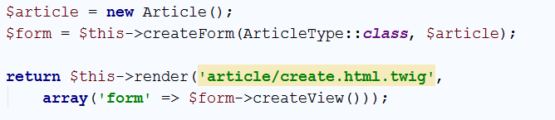

What is this code doing? It’s simple – it **creates a new article**. Then it **creates** a **new form** from the template we’ve created earlier and tells the **form** that it **should** **fill our new article**. Finally, it **sends the form to a** **view** that we are going to **render** on the screen. Render means draw. Symfony uses [Twig](http://twig.sensiolabs.org/). Twig is a [templating engine](https://en.wikipedia.org/wiki/Template_processor), which job is to **display our data** in an **easier** **way**, than creating the HTML by ourselves. The important part here is that we don’t **have such template yet** and PhpStorm (IntelliJ IDEA) tells us, by making **yellow rectangle** over the name of our template. To create it, just click on the template name and then press **[Alt] + [Enter]**. This will open a context menu in which you call tell your IDE to create the template for you:



Then you need to choose the first option:

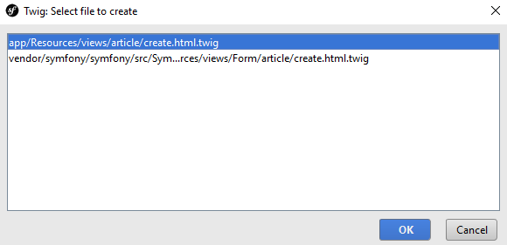

Congrats, you are looking at an **empty template**. Write the following code:

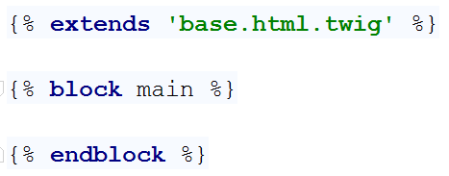

This code does 3 things. The **first one** is to ‘extend’ an existing template. What does that mean? It means, that **we’ve** **created the base design of the blog for you**, including all **styles** and **scripts** that you may need. **You** **can** now simply **reuse** this **base** **template** in all of the templates you are going to create. The **second** statement replaces a block called “**main**” in the base template. This means that all of the HTML in the base template for the “**main**” block will be replaced by the code you are going to write in a second.

Just because we don’t want you to focus on HTML and Twig, we will give all of the code, that you need to write in the main block:

|  |
| --- |
| <**div class="container body-content span=8 offset=2"**>  <**div class="well"**>  <**form class="form-horizontal" action="**{{ path(**'article_create'**) }}**" method="POST"**>  <**fieldset**>  <**legend**>New Post</**legend**>   <**div class="form-group"**>  <**label class="col-sm-4 control-label" for="article_title"**>Post Title</**label**>  <**div class="col-sm-4 "**>  <**input type="text" class="form-control" id="article_title" placeholder="Post Title"  name="article[title]"**>  </**div**>  </**div**>   <**div class="form-group"**>  <**label class="col-sm-4 control-label" for="article_content"**>Content</**label**>  <**div class="col-sm-6"**>  <**textarea class="form-control" rows="6" id="article_content"  name="article[content]"**></**textarea**>  </**div**>  </**div**>   {{ form_row(form._token) }}   <**div class="form-group"**>  <**div class="col-sm-4 col-sm-offset-4"**>  <**a class="btn btn-default" href="**{{ path(**'blog_index'**) }}**"**>Cancel</**a**>  <**button type="submit" class="btn btn-primary"**>Submit</**button**>  </**div**>  </**div**>  </**fieldset**>  </**form**>  </**div**> </**div**> |

However, let’s explain few parts of that template.

The first part we are going to discuss is:



We are using some css class, this part you should be familiar with. The really interesting parts are the **action** and **method** attributes of our form. First, we are going to talk about the method. This attribute defines what type of [request](http://www.w3schools.com/TAGS/ref_httpmethods.asp) we are going to use. To simplify things, let’s explain the requests shortly. The request we are going to use is “**POST**”. That means that we want to **send** **data** to some place. In our case, it tells the [HTTP](https://en.wikipedia.org/wiki/Hypertext_Transfer_Protocol) protocol that we want to **send our title and content** to a place in our blog. The other type of request that we’re interested in is “**GET**”. It tells HTTP that we want to **get** **some** **data** from somewhere. There are other types of requests, but we’re not going to bother you with them now. Let’s talk about the **action**. The action attribute defines **from**/**to** where we want to **GET**/**POST** our data. Remember the name of the route we gave our function earlier? Yeah, we want to send a **POST** **request** with our **title** and **content** **back** to the **function** we’ve created earlier. We will see how to use the data from the request later on.

The second part from the template that deserves a quick look is:

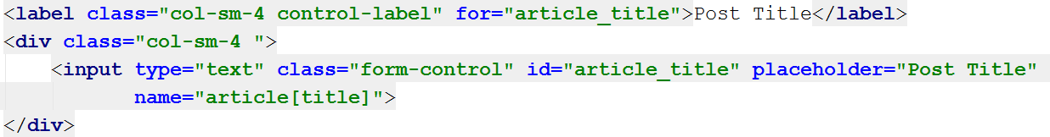

The first thing to notice is that the **for** attribute of the **label** and the **id** attribute of the **input** have the same value. Now take a look at the **name** attribute of the **input**. It looks like dictionary value. When you are mapping your entities in the twig templates, it’s important to note that the first part of the **name** is the **name of the entity**. In the square brackets, we put the **name of the field** from the entity we’re going to fill.

Another interesting thing is:



This is a special twig code. It creates a new **invisible** **field** in our form, that validates our form. Without it, our form won’t work. It you want to know more you should check about [CSRF](https://en.wikipedia.org/wiki/Cross-site_request_forgery).

Finally, one more special twig code that we saw earlier as well:



This “path” command uses route name, and redirects to the given route.

Enough for the templates for now, let’s start the blog and see if it works. To do that we need to open the Terminal/CMD in the root folder of our blog, or use the built-in terminal in PhpStorm (IntelliJ Idea). Don’t forget to start MySQL if you haven’t by now. Enter the following command:

|  |
| --- |
| php bin/console server:run |

If everything works, you should see this:



Open the browser and go to the address. You should see almost empty page. Now you need to register a new user and login. After login, in the URL enter <http://localhost:8000/article/create>. It should redirect you to form like this one:

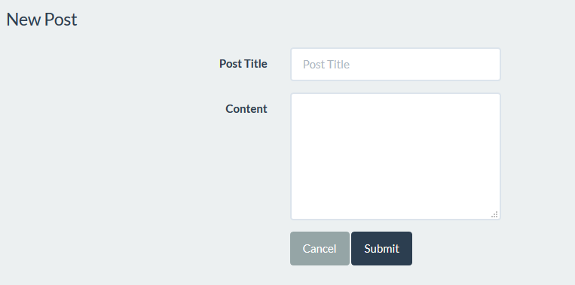

**Fill the form and click** “Submit”. The **page gets refreshed**, but if we check the table in the **database**, **it is empty**. Let’s fix the problem. Get back to your function in the article controller. The problem is that we’ve never used the data from our form. Add to your function the following code:

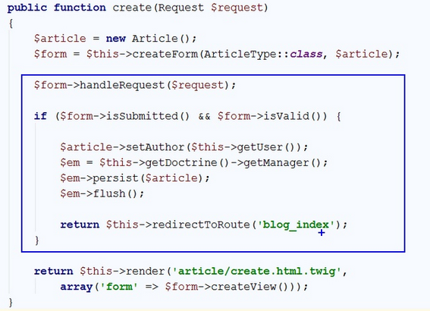

This code **takes the data from request (make sure the imported “use” statement at the beginning of the class is Symfony\Component\HttpFoundation\Request)** and **fills** the **form**. After the form is filled, we check if there is **any data** in the form and if it **is valid**. If everything is okay, then we get the currently **logged** **in** **user** and assign him as **author** of the **article**. Then we get the **entity manager** from **doctrine** and using the “persist” function we **add** our **new article** in the **database**. Finally, we call the “flush” function, which sends the article to our database. **After** the article is **sent** to the database, we **redirect** the **view** to the **index page** of our blog.

While we’re changing the code, open the base template:

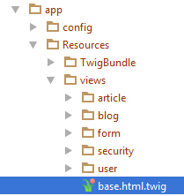

Find this part of the code:

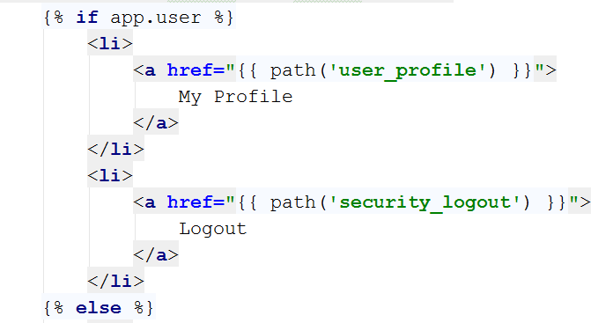

Add a new “<li>” element which will redirect to the **create article** page:

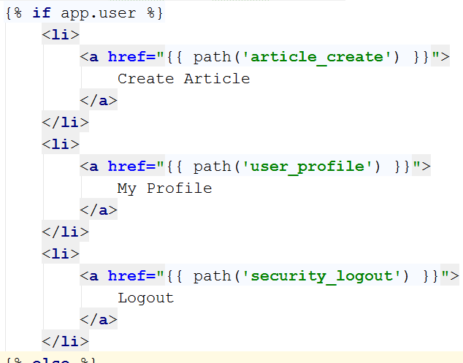

Let’s go to our blog and login. Now on the right-side of the navigation bar, we see the new button:



Let’s try to create new article. After pressing the “**Submit**” button, we should get redirected to the home page. Let’s see if we got anything new in the database. In HeidiSQL, open the **articles** table:



Hooray, we did it! Now we can create articles. The problem is that we can’t see them on our blog. Let’s implement that.

# Listing Articles

## Listing All Articles

Let’s go to the home controller. When you open it, you will find a function called “indexAction”. Its **only** **job** at the **moment** is to **call** the **index** **view**, without any data. We will change that. **Write** the following **code** in the **beginning** of the **function**:



This will get all of our articles from the database. Let’s pass them to the view. Edit the return statement like this:



We’re done here, go to the view, and examine it:

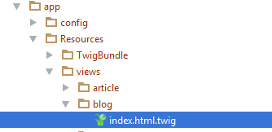

You should see this:



In the main block, write the following code:

|  |
| --- |
| <**div class="container body-content"**>  <**div class="row"**>  {% **for** article **in** articles %}  <**div class="col-md-6"**>  <**article**>  <**header**>  <**h2**>{{ article.title }}</**h2**>  </**header**>   <**p**>  {{ article.summary }}  </**p**>   <**small class="author"**>  {{ article.author }}  </**small**>   <**footer**>  <**div class="pull-right"**>  <**a class="btn btn-default btn-xs"  href="#"**>Read more **&raquo;**</**a**>  </**div**>  </**footer**>  </**article**>  </**div**>  {% **endfor** %}  </**div**> </**div**> |

There are few key moments that we want to take a look at. The first one is:



This is a simple foreach loop in twig. It will traverse the array of articles we’ve sent to the view through the controller. There is also a closing statement few lines below:



Between those two rows, there are a couple of twig calls. The first one is:



This will print the title for each article. We have the same thing for the summary and author of the article.

For now, let’s start the blog and see what we have:

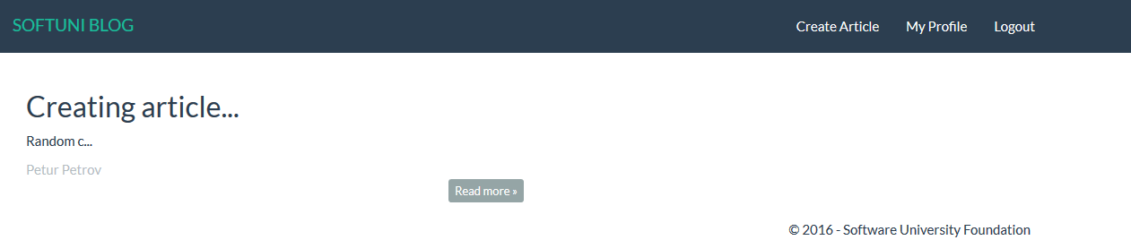

It works! Let’s create few more articles:

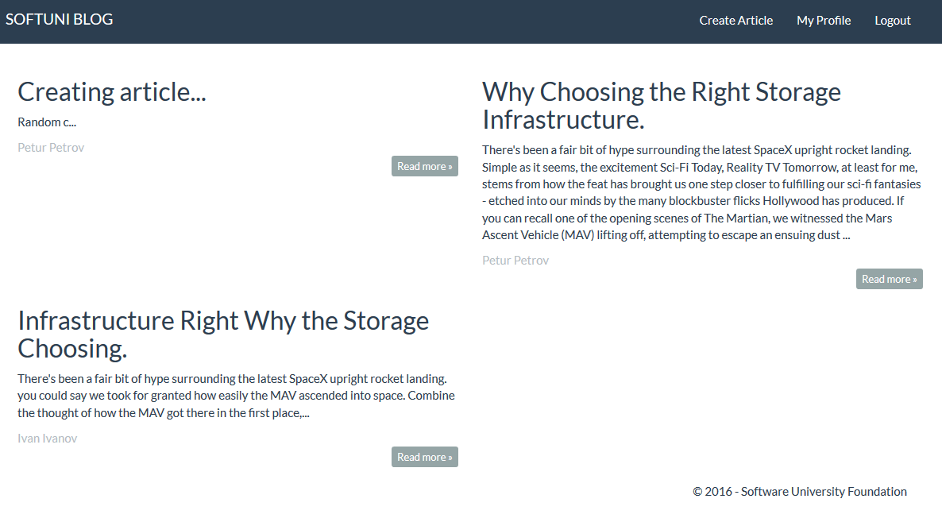

Looks good. The problem is that if we press “**Read more**” nothing happens. We should fix that.

## Showing Single Article

To implement the single article page, we need to go back to the article controller. Create the following method:

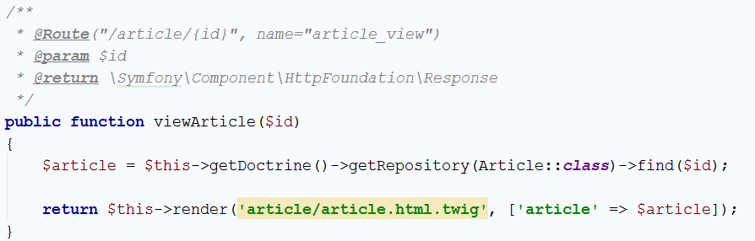

Let’s take a look at the annotations. The route annotation is having curly braces (‘{‘, ‘}’) and some parameter inside them. That is the parameter, that the function takes. Everything else is standard. If we take a look at the function, we can see that we are looking for a specific **id** in the database. This row will give us only the article with the given **id**. Then we send it to the view. Create the view, like we did earlier. The generated view will contain the base structure we are already familiar with:



Write the following code in the main block:

|  |
| --- |
| <**div class="container body-content"**>  <**div class="row"**>  <**div class="col-md-12"**>  <**article**>  <**header**>  <**h2**>{{ article.title }}</**h2**>  </**header**>   <**p**>  {{ article.content }}  </**p**>   <**small class="author"**>  {{ article.author }}  </**small**>   <**footer**>  <**div class="pull-right"**>  <**a class="btn btn-default btn-xs" href="**{{ path(**'blog_index'**) }}**"**>back **&raquo;**</**a**>  </**div**>  </**footer**>  </**article**>  </**div**>  </**div**> </**div**> |

This code is really simple, with the only difference from the previous one being that we have only one article and we are printing the content instead of the summary.

Let’s start the blog and see if it works. The answer is no, it doesn’t. Right now, the button read more doesn’t redirect to the right route. Let’s go back to the index view and find this piece of code:



Change it to:



Let’s try it now:

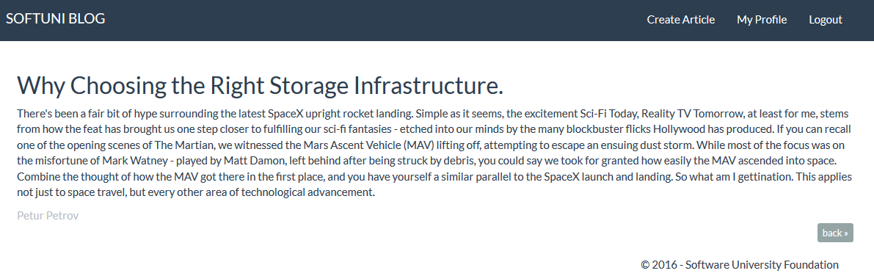

Congratulations! If everything works okay, you’ve just created a very simple blog system where users can log in and post articles.